DEVELOPER OPPORTUNITY | REQUEST FOR INFORMATION / QUOTATION
Ballot Result Slip OCR & Data Capture System
A lightweight brief for developers and solution partners
THE NEED
We require a system that receives scanned or photographed election result slips, extracts the relevant printed and handwritten information, validates the captured data, and stores approved results in a structured database with a complete audit trail.

MVP SCOPE  - Upload image or PDF result slips from desktop or mobile.  - Improve image quality: crop, rotate, de-skew and reduce noise.  - Identify the slip/template type and extract key fields and table values.  - Show extracted values beside the source image for human review and correction.  - Apply configurable validation rules, totals and checks for missing, mismatched or duplicate pages.  - Approve or reject the complete capture and save all linked pages under one result record.  - Search, view and export captured results; retain source files and change history.  TYPICAL DATA TO CAPTURE  Election/event identifiers; province, municipality, ward and voting district; station details; party/candidate names; vote counts; totals; rejected/spoilt ballots; signatures, timestamps and notes, where present.  Final fields will be confirmed against representative slip samples during discovery. | SOLUTION EXPECTATIONS  - Accurate enough for assisted capture; uncertain fields must be flagged with confidence scores.  - Support multiple layouts without rebuilding the complete system for each new slip type.  - Secure role-based access, audit logging and protection of sensitive election data.  - Provide simple integration with existing systems through a documented REST API and common CSV/JSON imports and exports.  - Deployable in the agreed environment, with practical offline or low-connectivity options considered.  - The solution must cost very little to implement and operate, using free or open-source components wherever practical.  - Architecture and stack remain open, but licensing, infrastructure, support and operating costs must be minimal and transparent.  EXPECTED DELIVERABLES  - Working MVP with source code and database schema.  - Configuration for agreed sample slip formats.  - Installation/deployment package and technical documentation.  - User guide, testing evidence and knowledge-transfer session.

MANDATORY MULTI-PAGE RESULT-SLIP RULES
1. Identify and group: Use the shared barcode/slip reference, election, ballot type, voting district/station and 'page X of Y'. The R page 1/2 and R page 2/2 samples must form one result. Never rely on filename or upload order alone. | 2. Require a complete set: Keep the result Incomplete and block approval or final export until every expected page is present, correctly ordered and linked to the same logical slip.
3. Control exceptions: Flag missing, duplicate, mismatched or conflicting pages. Manual linking or unlinking requires an authorised user, a recorded reason and a complete audit entry. | 4. Consolidate once: Extract all linked pages into one result, aggregate rows and totals without double counting, retain every source image, and expose the combined result plus page references through the API and exports.

WHAT TO INCLUDE IN YOUR RESPONSE
Approach: proposed solution and OCR/handwriting strategy • Experience: relevant OCR, document-processing or data-capture work • Plan: MVP timeline, team and key assumptions • Commercials: an itemised low-cost proposal covering build, licensing, hosting and support • Proof: suggested proof-of-concept using supplied anonymised samples
MVP SUCCESS: A user can submit a supported single- or multi-page slip, review the consolidated extracted data, correct exceptions, approve it and retrieve the result with all linked source pages and audit history.
Ballot Result OCR System | Developer Brief | September 2026

APPENDIX A | SUPPLIED REFERENCE MATERIAL
Sample Ballot Result Slips
These supplied samples illustrate the different ballot layouts and real-world capture conditions the solution must accommodate, including handwriting, perspective distortion, folds, shadows and signatures. Samples 2 and 3 are linked pages of the same regional (R) result slip and must be processed as one logical document.
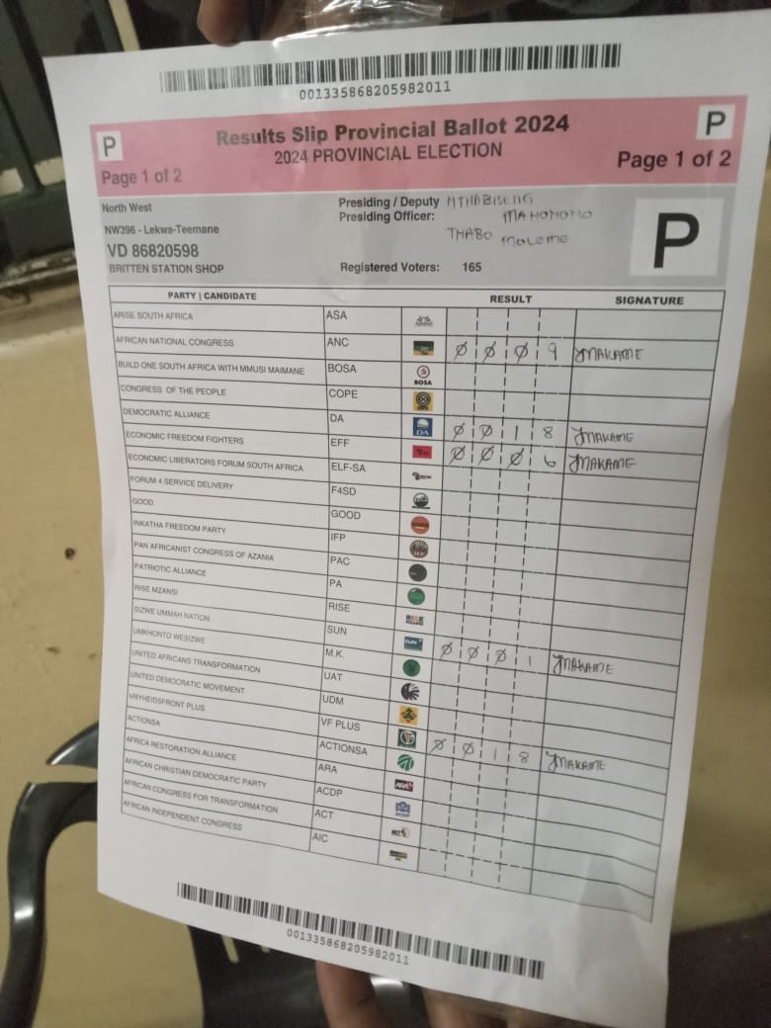  Sample 1 - Provincial ballot result slip | 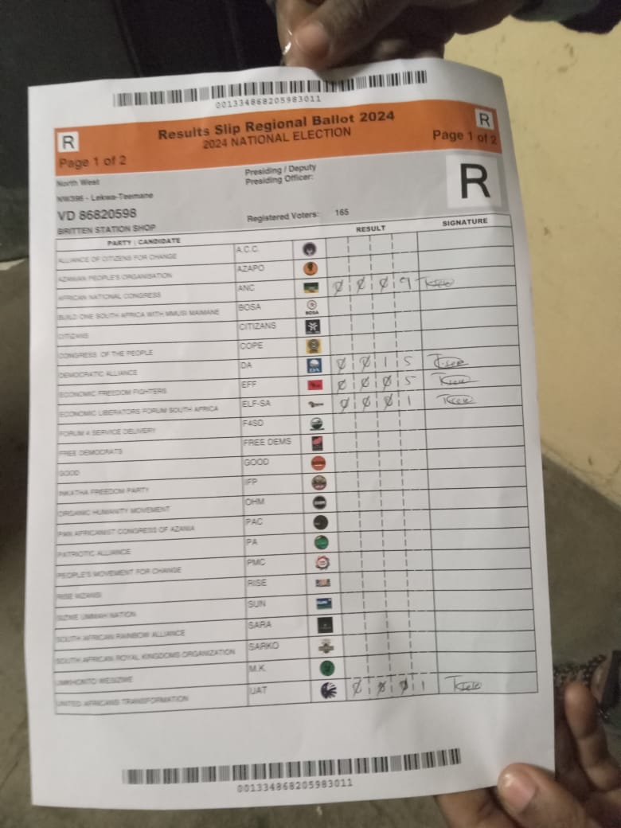  Sample 2 - Regional ballot result slip, page 1
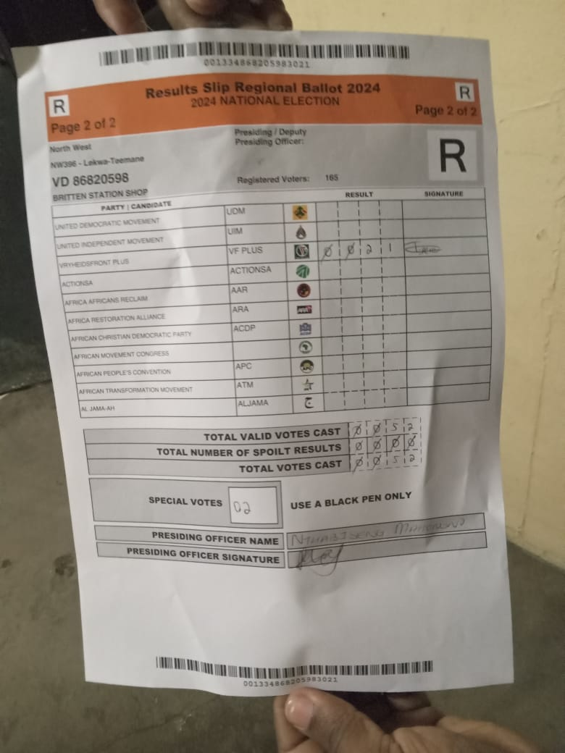  Sample 3 - Regional ballot result slip, page 2 | 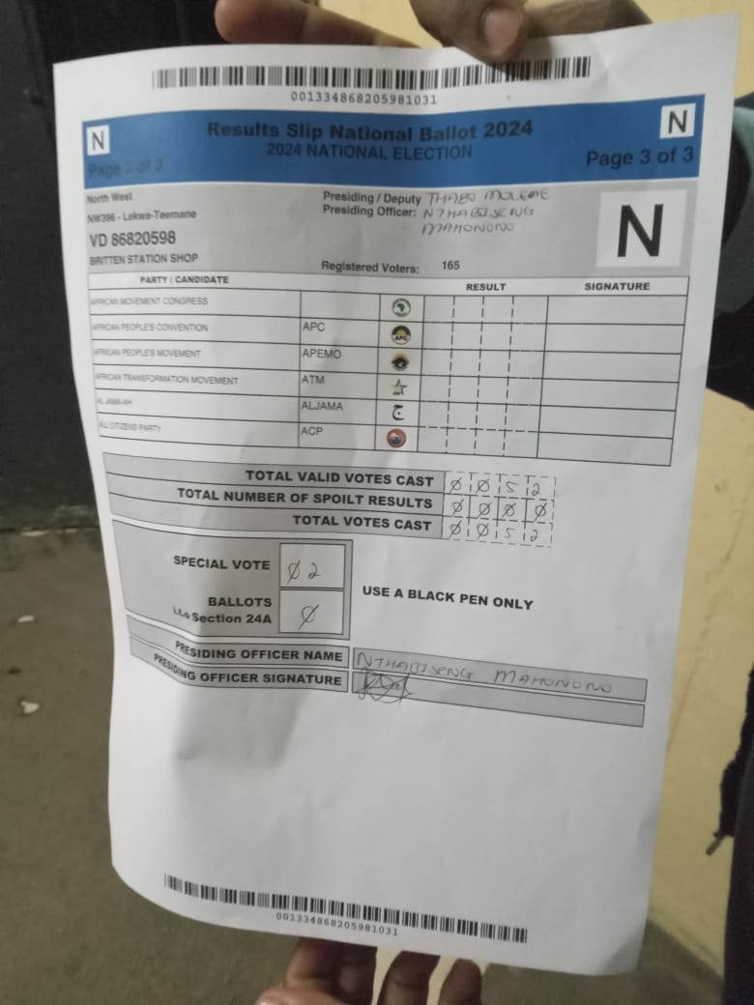  Sample 4 - National ballot result slip
Ballot Result OCR System | Sample Slip Appendix

